The Boston Globe

By Cate McQuaid Globe Correspondent
February 16, 2016

Crafting Strong Messages
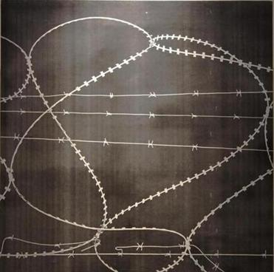
Jocelyn Chemel’s “Barbed Scribble.”
South African Jocelyn Chemel makes barbed wire the central motif in her multi-media show at the Mayor’s Neighborhood Gallery at City Hall. It’s a tough hallway space. Brick walls require artworks to be strung from the ceiling. They’re not flush, and hard to light.
Chemel’s work largely withstands these obstacles. Barbed wire speaks to South Africa’s history of apartheid and violence, but the image has plenty of resonance here, and anywhere fences are built to keep people out — or in.
Her strongest works are digital photographs, sometimes manipulated. “Barbed Scribble” simply traces the loop-de-loop of wire; it looks like chalk on a blackboard, as if it were an elementary school lesson. For “Endure,” Chemel plugs colors used by the once-powerful Ndebele tribe into the bleached-out grid of a fence, with ghostly outlines of wire twisting in front. Other works needlessly include text; barbed wire sends a strong enough message without it.
Jocelyn Chemel: Barbed
At Mayor’s Neighborhood Gallery, Boston City Hall, 1 City Hall Square. 617-584-0733, www.jocelynchemel.com/events-and-press/

